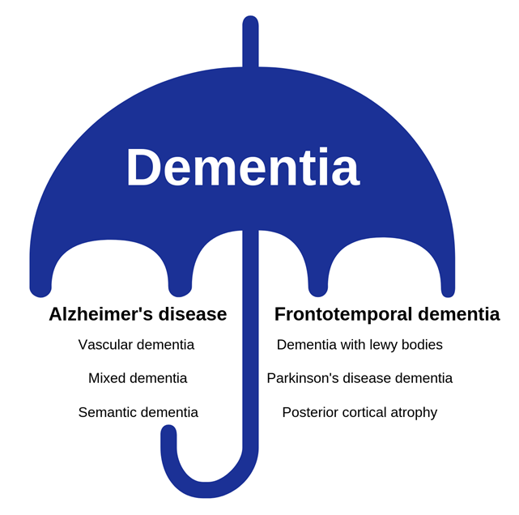
Dementia: Do we know more than we think?
The University of Exeter requires psychology undergraduates to complete a research project as part of their final year programme. This year, a group of 10 students joined the REACH team to do a dementia-related research project. The following summary has been written by the group to highlight the key findings from their work.
“In this study, we collected responses from 321 members of the general public (aged 18 to 89 years) around Exeter city centre during December 2018. The study asked people about their awareness and understanding of dementia, including specific questions about two subtypes: Alzheimer’s disease and Frontotemporal dementia.
Results showed that people in Exeter were more knowledgeable about Alzheimer’s disease (98.4% of people had heard of it) than about frontotemporal dementia (22.5% of people had heard of it). While levels of knowledge were modest, interestingly, people performed a little better than they expected regarding their knowledge of Alzheimer’s disease (rating their expected accuracy at 52% correct compared to their actual scores of 62%).
While there was no difference in knowledge score between men and women, people who have known someone with dementia had a better understanding of symptoms of Alzheimer’s Disease and Frontotemporal dementia than people who have never known anyone with these conditions. However, having known someone with dementia did not result in greater knowledge regarding risk factors and treatment, suggesting that there are certain knowledge gaps which need to be addressed.
An additional aim of the study was to measure how worried people were about getting dementia in the future, and whether they were motivated to seek information about dementia . Consistent with previous research, family experience led to higher worry, whilst carer experience led to higher knowledge. Although knowledge did not differ between men and women, women were significantly more worried about dementia than men. Worry also was found to impact desire to seek information, i.e. when a person’s worry increased, so too did their desire to seek information.”
Thank you to everyone who took part in the study.
Useful links for more information:
Alzheimer’s Society- https://www.alzheimers.org.uk/
About Frontotemporal dementia- https://www.alzheimers.org.uk/about-dementia/types-dementia/frontotemporal-dementia
About Alzheimer’s disease- https://www.alzheimers.org.uk/about-dementia/types-dementia/alzheimers-disease
NHS support- https://www.nhs.uk/conditions/dementia/about/

